# Steps to create a service connections

1. Login to the Azure DevOps portal.

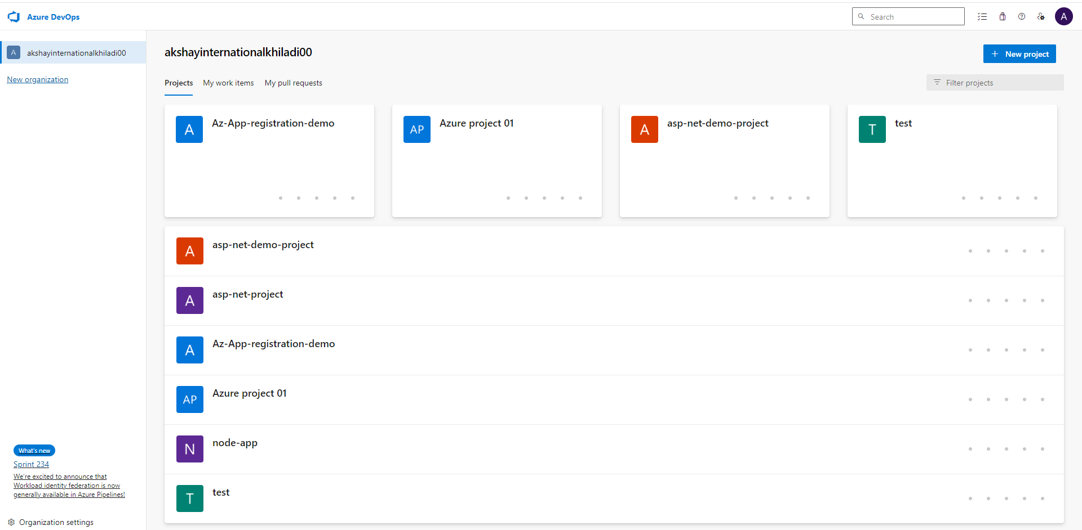

2. Select your project and click on the Project Setting.

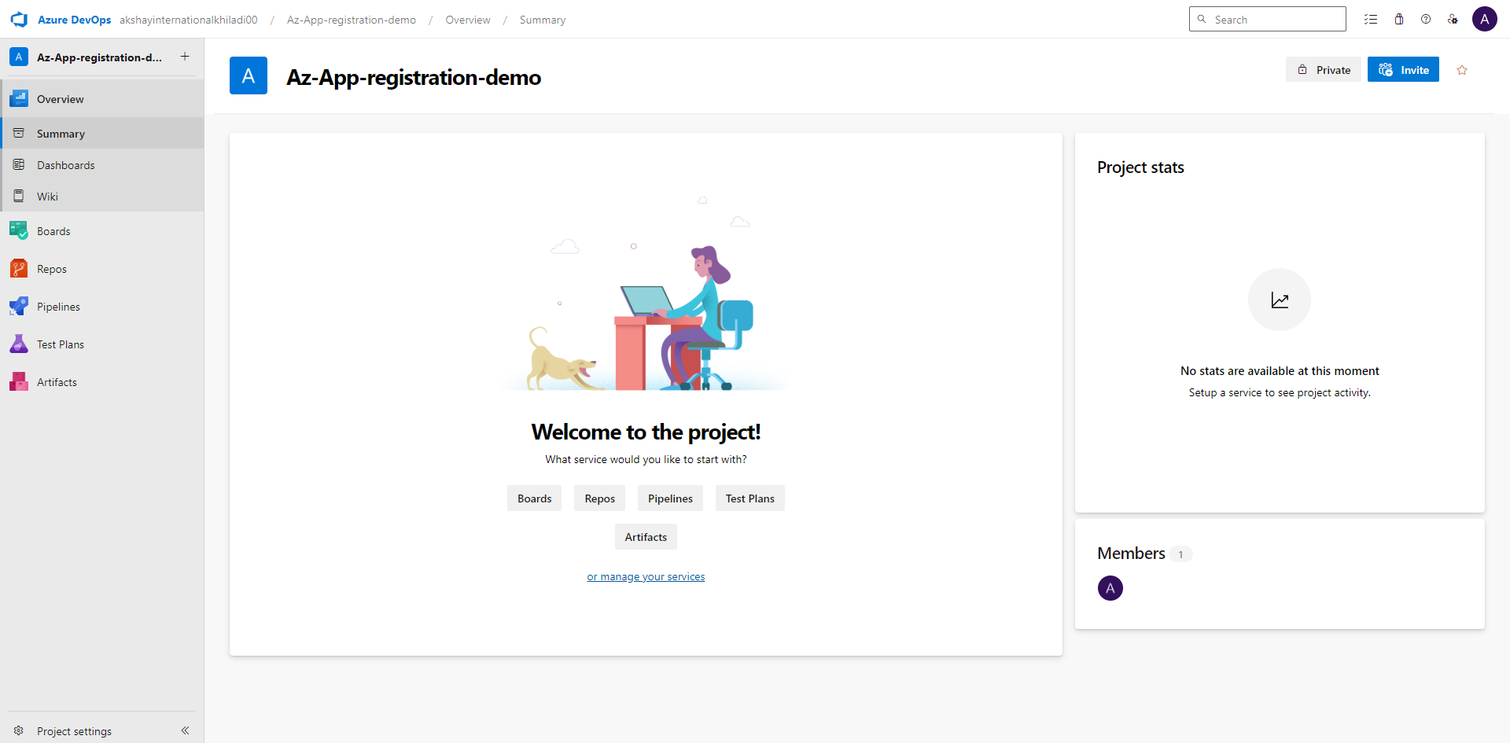

3. Click on project setting (On the bottom left)

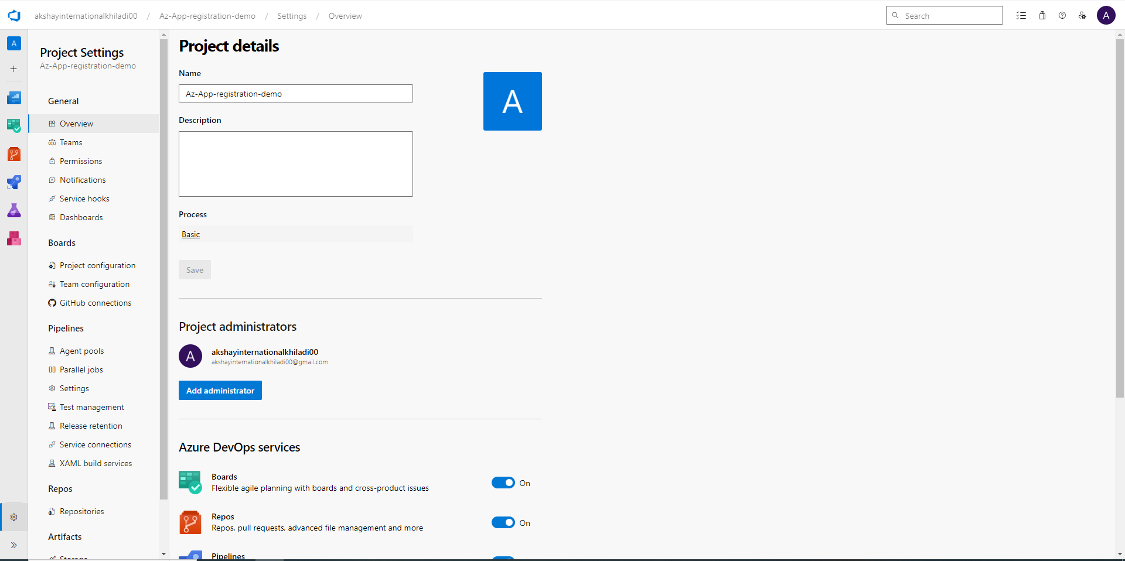

4. Click on service connection

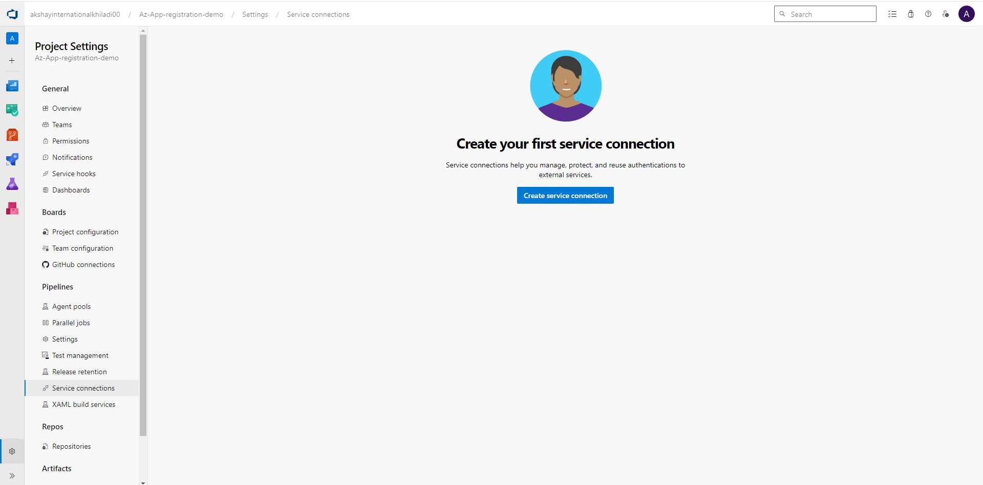

5. Create service connections - click on Azure resource manager and hit next.

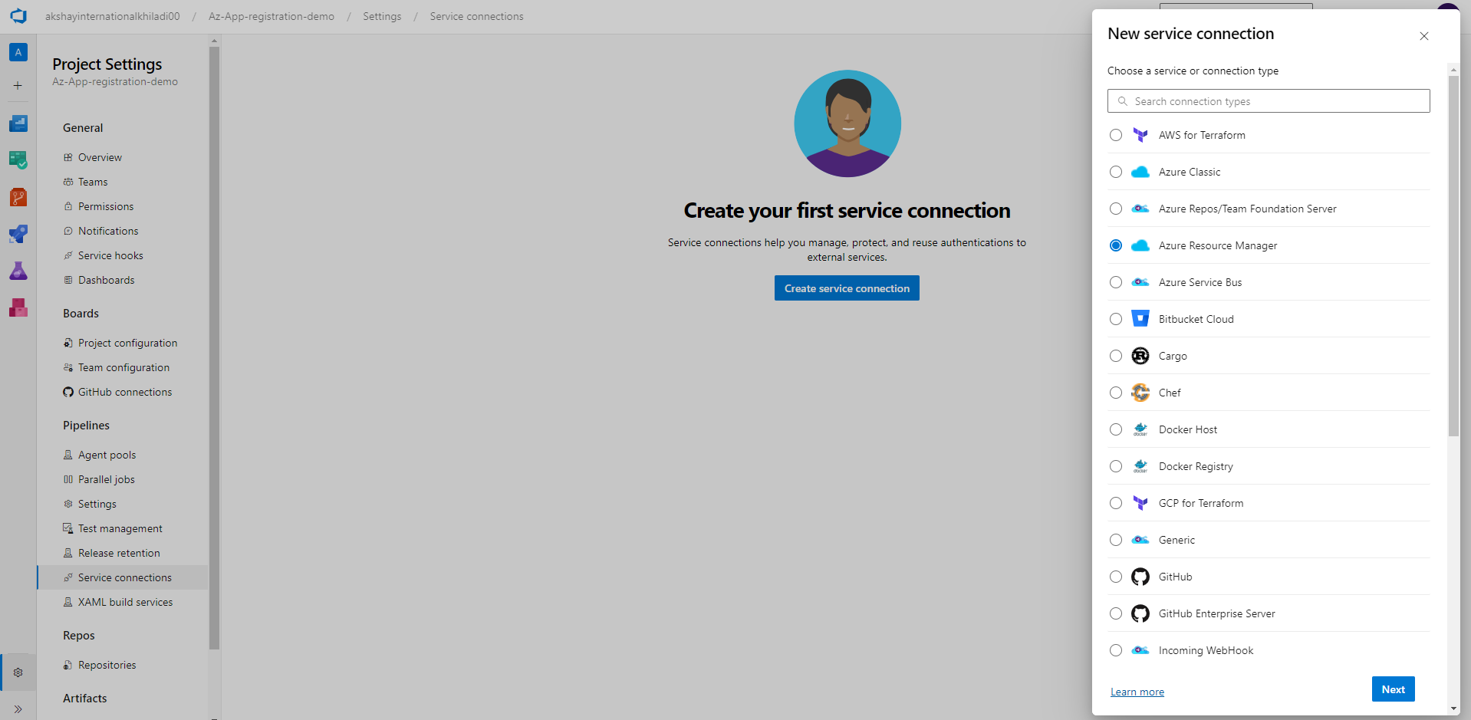

6. On New Azure service connection – select service principal (Manual) – Hit next

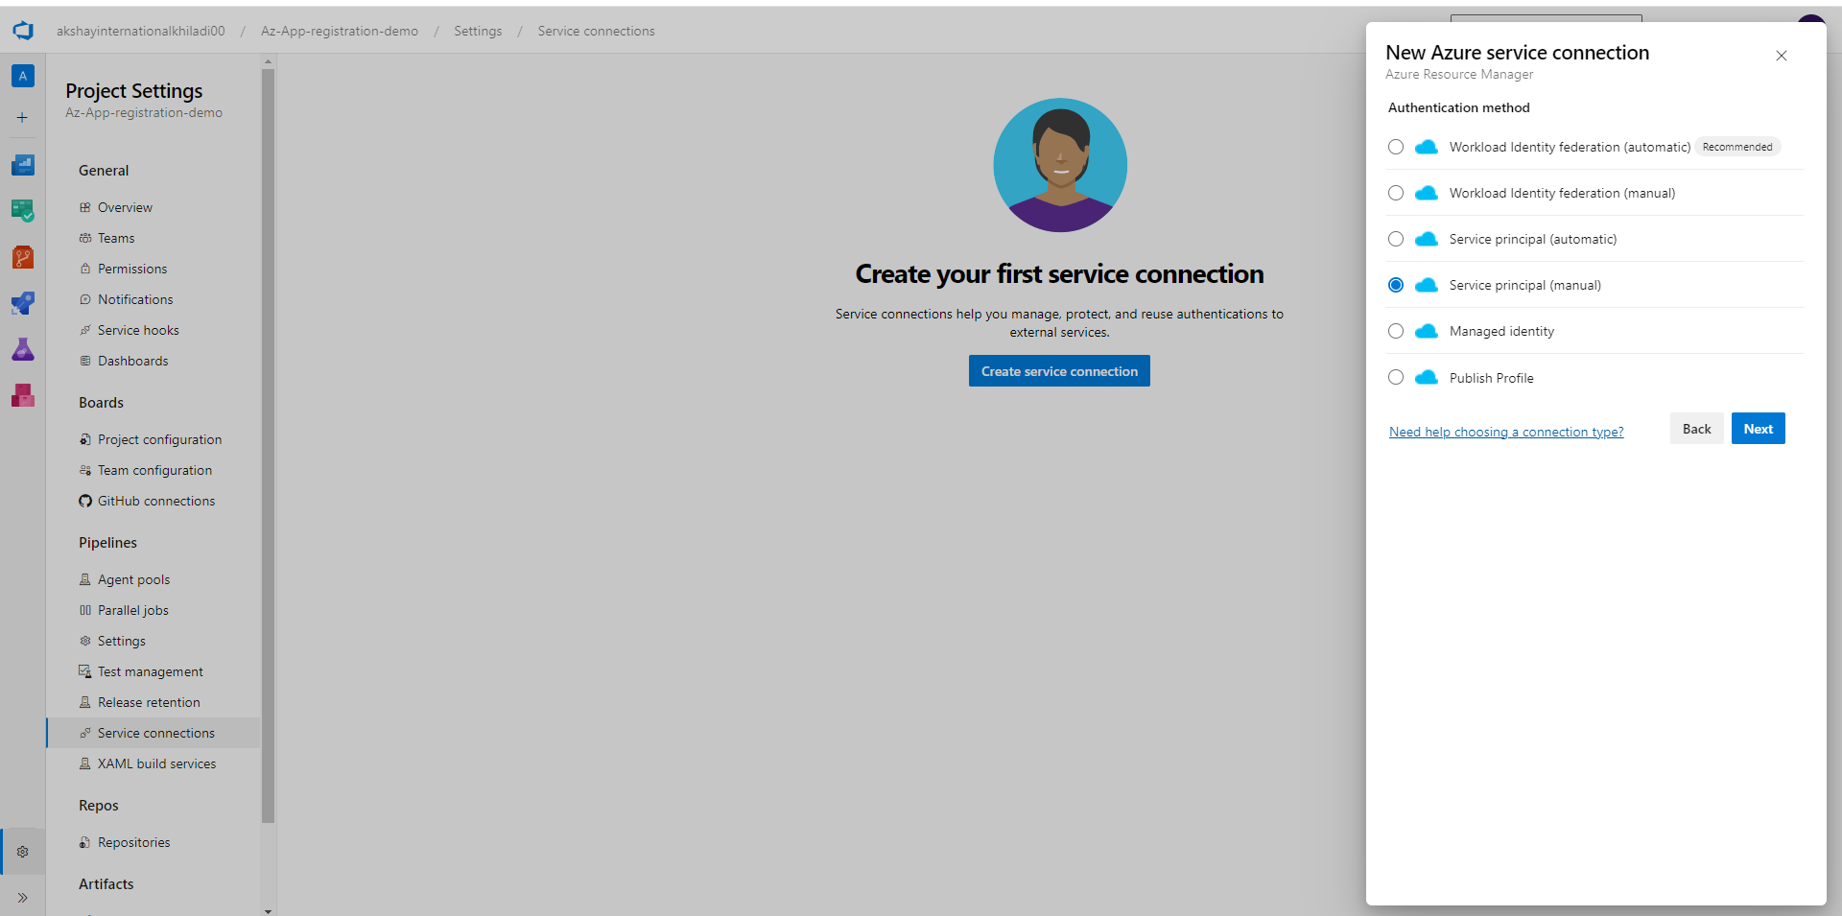

7. After next we need to fill all the required tabs.

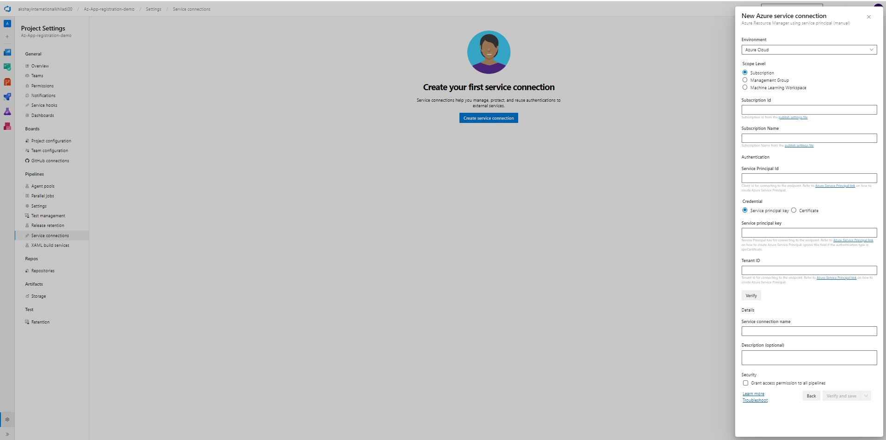

8. We need to fill **Subscription Id** form **Azure cloud (subscription tab) and** subscription name

